3.93: a) Taking all units to be in km and h, we have three equations. We know that heading upstream 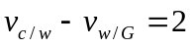 where 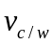 is the speed of the curve relative to water and 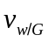 is the speed of the water relative to the ground. We know that heading downstream for a time 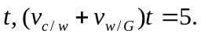 We also know that for the bottle 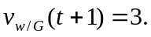 Solving these three equations for 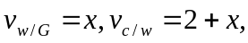 therefore 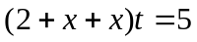 or 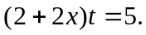 Also 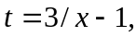 so 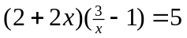 or 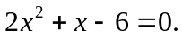 The positive solution is 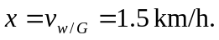
b) 